
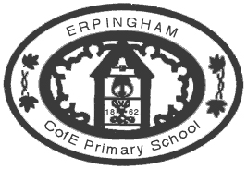
Erpingham C of E Primary School
School Road
ERPINGHAM
Norwich
Norfolk
NR11 7QY

T: 01263 761365
E: head@bsf.norfolk.sch.uk
Headteacher: Mrs Angie Hamilton

06/02/2019

Dear Parent/Carer,
WAGTAILS SWIMMING LESSONS AT AYLSHAM HIGH – corrected date below
Wagtails will be starting swimming lessons after half term, on a Friday afternoon. They will travel there by minibus and return before the end of the day.
They will swim on the following Fridays:
1st March 10th May
15th March 14th June
29th March 28th June
26th April 12th July

Your child will need:
- Swimsuit/ trunks (no bikinis)
- Swimming hat
(available from Aylsham High for £1 if you cannot source your own. Please bring money in before the first session to the office so we can check they have stock for you)
- Goggles (if your child normally wears them)
- Towel

Any problems or queries please see me.
Yours sincerely
Mrs Rowe (PE Co-ordinator)

