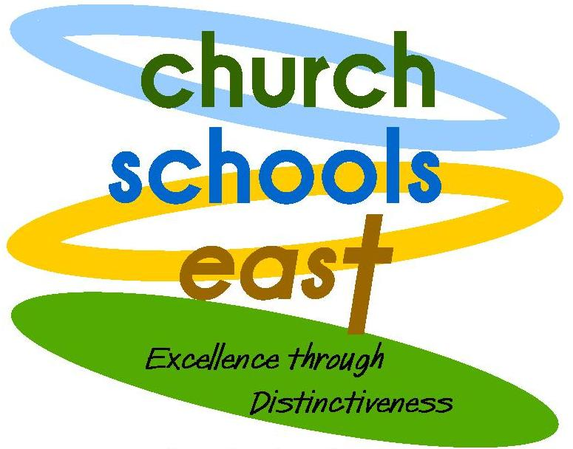
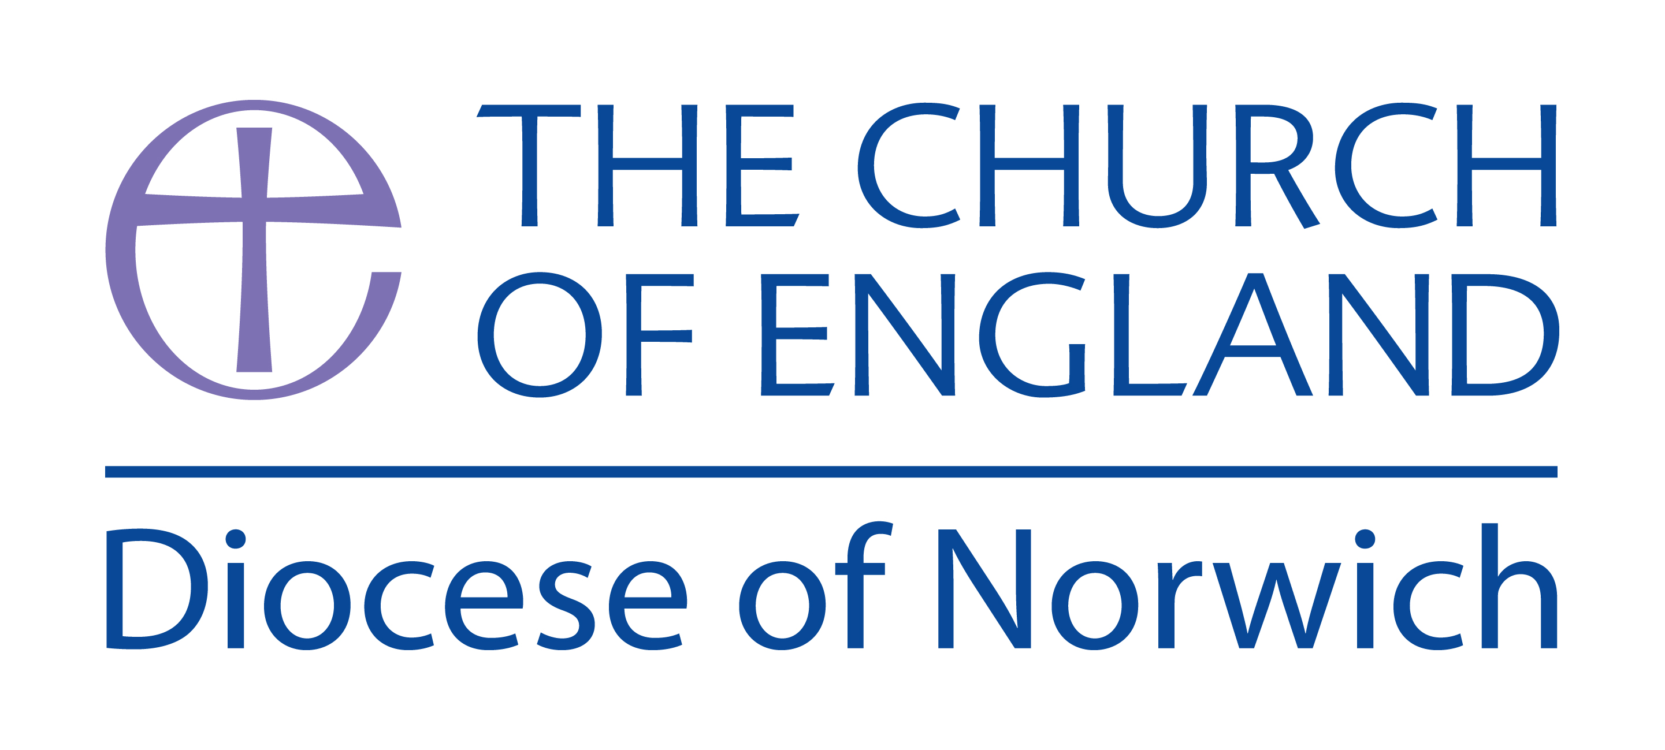

National Society Statutory Inspection of Anglican Schools Report

Erpingham Voluntary Controlled Church of England Primary School
School Road
Erpingham
Norwich
Norfolk
NR11 7QY
Diocese: Norwich
Local authority: Norfolk
Dates of inspection: 9th July 2012
Date of last inspection: 11th March 2008
School’s unique reference number: 121036
Headteacher: Mr Simon East
Inspector’s name and number: Dr Shirley Hall 390

School context
Erpingham is a very small rural school with 31 pupils on roll, 11 of whom are flexi-schooled and therefore partially home educated. By becoming a centre for flexi-schooling the school roll has doubled within the last eighteen months. The school has a reputation for welcoming and supporting pupils who have failed to flourish in larger establishments and a high proportion of pupils are supported by school action plus or have statements of special needs. Pupils are drawn from a wide geographical area. The school has a close link with the nearby local parish church and incumbent.

The distinctiveness and effectiveness of Erpingham as a Church of England school are good
The school’s Christian ethos inspires good teamwork and positive values. Pupils are well-cared for and mix together across the age ranges in a mutually supportive way. Engagement with parents and carers is a strength of the school, as are the links with the local church. The school focuses on building and promoting its church school identity in a planned and developmental way.

Established strengths
- A mutually supportive team of staff, governors, volunteers and families which supports the Christian identity of the school in a variety of ways.
- Good links with the church and village communities centred on shared opportunities for worship
- An inclusive family atmosphere in which both children and adults feel they have a part to play.

Focus for development
- Through collective worship and class discussion, explore ways of linking the Christian values of the school more overtly with the Forest School system in pupils’ understanding,
- Use the current refurbishment of the library as an opportunity to create an attractive worship space, including a Christian focus.
- Devise and implement a plan for governors and pupils to regularly monitor collective worship and discuss good practice.

The school, through its distinctive Christian character, is good at meeting the needs of all learners

Erpingham is a school with the needs of individual children at its heart; this is demonstrated in the caring, inclusive and mutually supportive nature of the school, as well as in the carefully organised pattern of personalised flexi-schooling arrangements. The school’s Christian ethos and values are shared with the families of all prospective pupils and form the bedrock on which the differing learning relationships are built. In this family-style atmosphere pupils are enabled to flourish, a parent reported: “it’s changed my son’s life and it’s changed my life”.
The school’s outdoor environment and its role as a Forest School shape its identity by encouraging positive attitudes to associated learning and a respect for the natural environment. Forest school lessons nourish the spiritual development of the children by providing them with times for reflection and moments of calm, as well as building self-esteem, confidence, co-operation and resilience. Pupils who spoke of the special nature of their school often identified themselves firstly and most readily with the ethos of Forest Schools before thinking of themselves as a Church School.
The school provides a rich variety of memorable learning experiences which have impacted upon pupils in different ways: a day visit to join with a much larger primary school, for example, inadvertently added to their appreciation of their own school situation – “we are more like one big family, we play together and we support each other”. A very different visit to the Julian Shrine in Norwich gave pupils the space to engage with their spiritual side. The school benefits from the talents of several parents who support the school in music and the creative arts. Governors and parents together are currently redesigning the school’s quiet seated area to become a spiritual garden.
The relatively new school council feels that it’s voice is heard in making decisions about issues and pupils were able to give examples of changes which had taken place as a result of their input, especially at playtime and in general school organisation. Pupils also take responsibility for a small size gardening enterprise where they grow and sell vegetables and fruit as well as producing baked goods. In the local community the school is also responsible for the central design of the village sign, which will be redesigned and refreshed at regular intervals, while in the world community a link with Nepal is in place.

The impact of collective worship on the school community is good
Collective worship is planned effectively around the “Values for Life” programme which is punctuated by monthly special services devised and run by the local church community for the school (Messy Church, Advent Lantern Procession, Easter Pilgrimage).
In the act of worship observed, children were engaged with the theme of hands and prayer; they sang with enthusiasm and answered questions with understanding. Following time for personal reflection and application of the message, the closing prayer used was the school prayer which had originally been written by the pupils, and is now a regular feature of collective worship. The school prayer, along with the Lord’s Prayer, is on display throughout the school. Pupils questioned later were unable to recall with confidence the themes and messages of earlier acts of collective worship, although evidence from parents showed that some of the children often shared the stories they enjoyed from worship with their families. Members of faith communities other than Christianity which are represented in the school confirmed that they felt comfortable and included when they attended any act of worship in school or in church.
The relatively small multi-purpose space available to the school for collective worship is not set up in such a way as to support and enhance the worship time. This has been noted by the school, which has begun implementing a refurbishment of the area.
The monthly special services have a significant impact upon the members of the school and were the acts of worship recalled in most detail by pupils. These services include opportunities for creative activities, celebration and real moments of awe and wonder; children and adults alike spoke movingly of the impact that the Advent Lantern Procession had upon them. Increasing numbers of adults from the church, families and wider community come together upon these regular special occasions and this has in turn impacted upon the strength of the links between church, school and community.

The effectiveness of the leadership and management of the school as a church school is good

The Headteacher, supported by the governors, has accurately assessed the school’s strengths and areas for development. The latter are brought together in a rolling Religious Character Action Plan which gives strategic direction to Erpingham’s growth as a church school. The school has responded effectively to the development issues arising in the last inspection with the introduction of “Messy Church”; the thoughtful rebranding of the school with the introduction of a child designed Christian logo; and a “stage not age” method of recording and reporting on spiritual development which also helps to assess the impact of the Action Plan.
The incumbent’s long standing relationship with the school as governor and pastor is the foundation stone of a close relationship between the church and school communities. This relationship is marked by the variety of regular monthly services, and sharing of news through the “In Touch” magazine and school display board in church. The link with the wider diocese is cemented by the valued partnership with the Diocesan School Support Officer and, recently with the visit of the Bishop of Lynn for the school’s 150th anniversary.
There is a strong collaborative team spirit at Erpingham. Governors, parents and staff identify the Christian values of the school as a key part of its identity: “they are not a conscious effort, but part of our life...we would be different if we were not a church school”. Simple parental questionnaires demonstrate that families are at least satisfied that the school lives out its Christian values in its internal structures and relationships and in its contacts with stakeholders and the wider community. The governor monitoring of collective worship is not yet in place; this was highlighted as an issue at the time of the last inspection.
SIAS report July 2012 - Erpingham Voluntary Controlled Church of England Primary School, School Road, Erpingham, Norwich, Norfolk NR11 7QY

